**Critical variables for manual medical review:**

**Ankle brachial index score- <0.4 indicate severe disease- check AE if entered or not; query site if site doesn’t enter AE Susan to create listing.**

**Framingham scores – check the calculation of HTN, AGE, cholesterol, DM scoring – explain that is just observing the site’s assessment and not something we would have the site change if it is scored incorrectly**

**Baseline- ensure cytogenetic and molecular testing done at baseline to confirm disease, CP-CML INFORMATION AT ENROLLMENT- check subject is treatment naïve and starting on the dasatinib, imatinib, nilotinib, or bosutinib. Susan to create listing cytogenetic testing- if not present will need to be added to the protocol deviations**

**Susan to create a listing to confirm start date of medication is after the informed consent date.**

Laboratory assessments - check lab values and see if any grade 3 or grade 4 and clinically significant lab values are included in AE as well. Patti to create ranges and check with Andreas to see if the list of values is acceptable.

AE of special interest list to determine which labs will be reviewed.

**Sokal scores Susan to create listing for if the score is present, but there are missing values.**

**AE- if ae includes treatment, check concomitant medication/ procedures. If SAE reported, make sure grade is not 1 or 2, most likely wouldn’t be an SAE if only grade 1 or 2. Not needed. Only need to be reported if higher grade, but if the site feels the need to report, then we don’t remove the SAE report. Check that Syenos is not doing this.**

**Visit summary pages- changes in cardiac or metabolic condition- if applicable, check if the event is registered in AE as well (for ex: coronary arterosclerosis) The form just says new of change in CV or/and Metabolic conditions- this could be improvement. Not able to create a listing for this.**

**Visit summary pages- Imatinib therapy- check when patient switched the TKI and match the start and stop date of TKI treatment. Need to compare Imatinib, Methotrexate combination therapy with the Imatinib therapy form to ensure the start and stop dates match. Same for Dasatinib and vincristine and Dasatinib, Methotrexate, cytarabine, 6 mercaptopurine, Dasatinib with Prednisone and intrathecal Methotrexate combination therapy.**

**When the patient switches TKI therapy, compare that there is a response assessment of progression.**

**Check box yes changed, then be sure there is a new TKI listed.**

**If the patient switches from the initial TKI, then followed only for survival, reason for change and what to their new regimen. Ensure, assessment data is not being captured for this patient. No more assessments only survival information.**

**Visit summary pages- Discontinuation of tki treatment- check when subject switched to different medication (CHEMO AND NON CHEMO- make sure the new treatment regimens are included in the Chemo and Non chemo section) See above.**

**Imaging assessments- EKG normal qtc within 400-440 or 460, Chest x ray, central ct and ECHO normal 55%-70% - check if any abnormality and clinically significant, report as AE TERM (for ex: if ekG abnormal for ex: atrial frbillation, v tach, or torsades de pointes when QTC>500, ECHO- low lvEF value <40% indicates heart failure need to be reported as AE) Susan to check if site says significant that the AE exists.**

**Response to index tki treatment tab- Susan to check if there is cytogenetic information entered in the EDC for the date of the response assessment.**

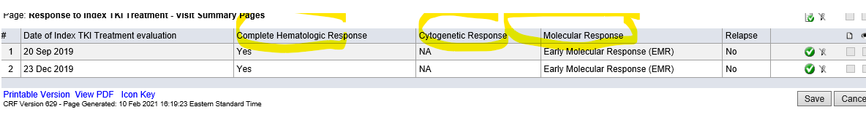

|  |  |  |  |
| --- | --- | --- | --- |
| **Type of response** |  | **Features** | **Test used to measure response** |
| **Hematologic** | **Complete Hematologic response (CHR)** | * **Blood counts returns to normal (platelets<450x10^9; WBC<10x10^9)** * **No blasts in peripheral blood** * **No signs or symptoms of disease- spleen return to normal size** | **CBC with differential** |
| **Cytogenetics** | **Complete Cytogenetic Response (CCyR)** | **No Philadelphia chromosome or BCR-ABL1 <1%** | **Bone marrow cytogenetics** |
| **Partial Cytogenetic Response (PCyR)** | **1%-35% of cells have Philadelphia chromosome** |
| **Minor Cytogenetic Response** | **35%-65% cells have Philadelphia chromosome** |
| **Major Cytogenetic Response** | **0-35% cells have Philadelphia chromosome** |
| **Molecular** | **Complete Molecular Response (CMR)** | **No BCR-ABL gene detected** | **Quantitative PCR using International scale** |
| **Major Molecular Response (MMR)** | **At least 3 log reduction in BCR-ABL mRNA level from standard baseline; or**  **BCR-ABL <0.1%** |
| **Early Molecular Response (EMR)** | **BCR-ABL <10% at 3 and 6 months** |
| **Deep Molecular Response (DMR)** | **BCR-ABL<0.01% OR bcr-abl< 0.0032%** |
| **Relapse** |  | * **Any sign of loss response (hematologic or cytogenic relapse)** * **1 log increase in BCR-abl1 transcript levels with loss of MMR should prompt bone marrow evaluation for loss of CCyR but is not itself defined as relapse (eg. Hematologic or cytogenic relapse)** |  |

* **Response to Index TKI treatment- make sure complete hematologic response recorded in response to TKI index treatment match the labs value.**
* **Response to Index TKI treatment- make sure Cytogenetic response recorded in response to TKI index treatment match with Bone marrow Biopsy/aspirate results and FISH result**
* **Response to Index TKI treatment- make sure molecular response recorded in response to TKI index treatment match with Molecular response PCR result and Genetic testing tab**



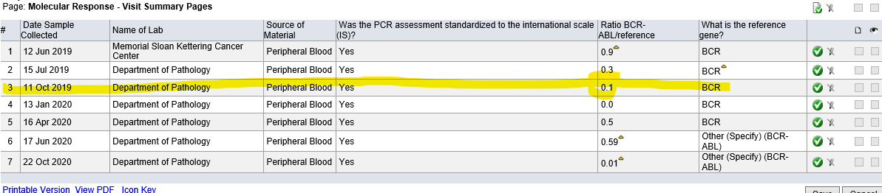

**Disease status tab- make sure whats recorded is matching to Response to TKI index treatment**

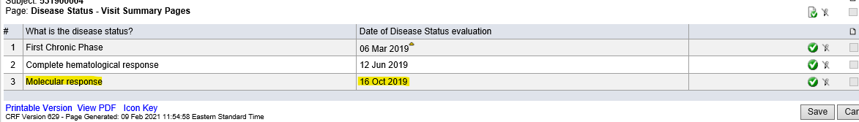

**Susan to create a listing to compare disease status to response to TKI index treatment.**